**Classes and class hierarchy**

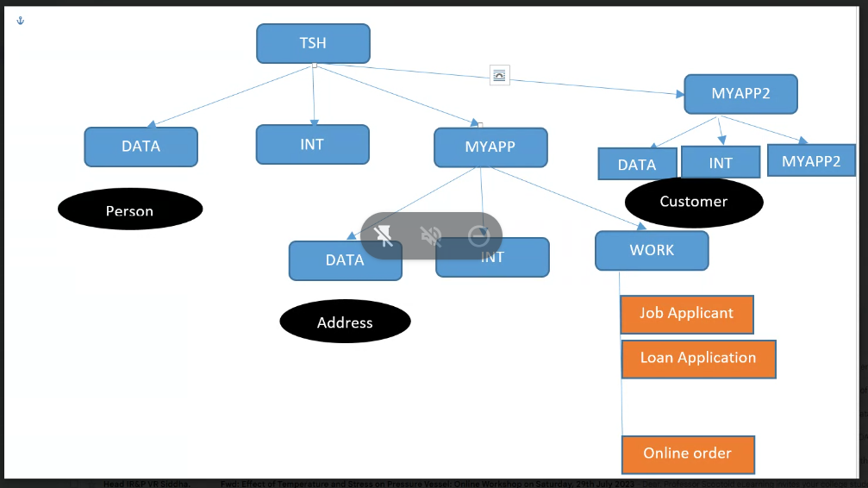

Data class---->All data types are stored in data class

Int class---->Integration rules when we want to connect to external

Work Class---->Because all the case type related info is stored here

If I want to reuse we create in organization level

If I don’t reuse than we use application level

If I want to use across the cases than we use work class